



GAUGING A SITE’S OPPORTUNITY FOR IMPROVEMENT:-

SITE COMPANY: CALIFOODNIA

PROJECT SITE: <https://califoodnia.in/>





* The title tag is optimized (has 30 characters and less than 55 character) but the title tag can be optimized further by adding a brand image in the title tag.
* Yes, there pages lack substance to a great extent. All their pages need a lot

more content in order to gain traffic and page rank.

* I came across only two errors, namely the search bar in the blog page and the social page.





WEBSITE’S STRENGHTS:-

* 1. The webiste homepage has perfectly optimized title and heading tags.
  2. The meta description has characters less than the pecified value enough for SEO and gaining a good rank.
  3. The website has good social media following on instagram and as a beginner to start with 4312 followers is really a good number.





WEBSITE’S WEAKNESS:-

1. The backlinks to the page are not good.
2. The posts by califoodnia don’t get good number of shares on social

media.

1. The content is very less and needs to be updated to get a good rank.





1. The website is currently handled by its 3 founders. The site can be further marketed by making joint ventures with the other good vloggers and food bloggers on instagram and facebook.
2. In todays time, facebook is on the verge of becoming outdated and has become a platform for the elder class.
3. On the other hand, the site has to focus more on instagram and their influencers. For eg:- The site can get into joint ventures with other instagram photographers and homemakers.





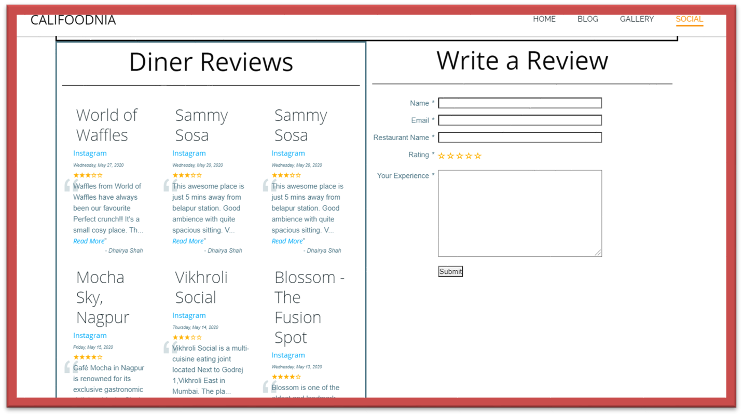

Here we can see that the write a review and dinner reviews is on the same page arranged side by side, this creates a mess and people usually don’t feel like reviewing the page.

Rather, a div block element with one below another can be great looking.

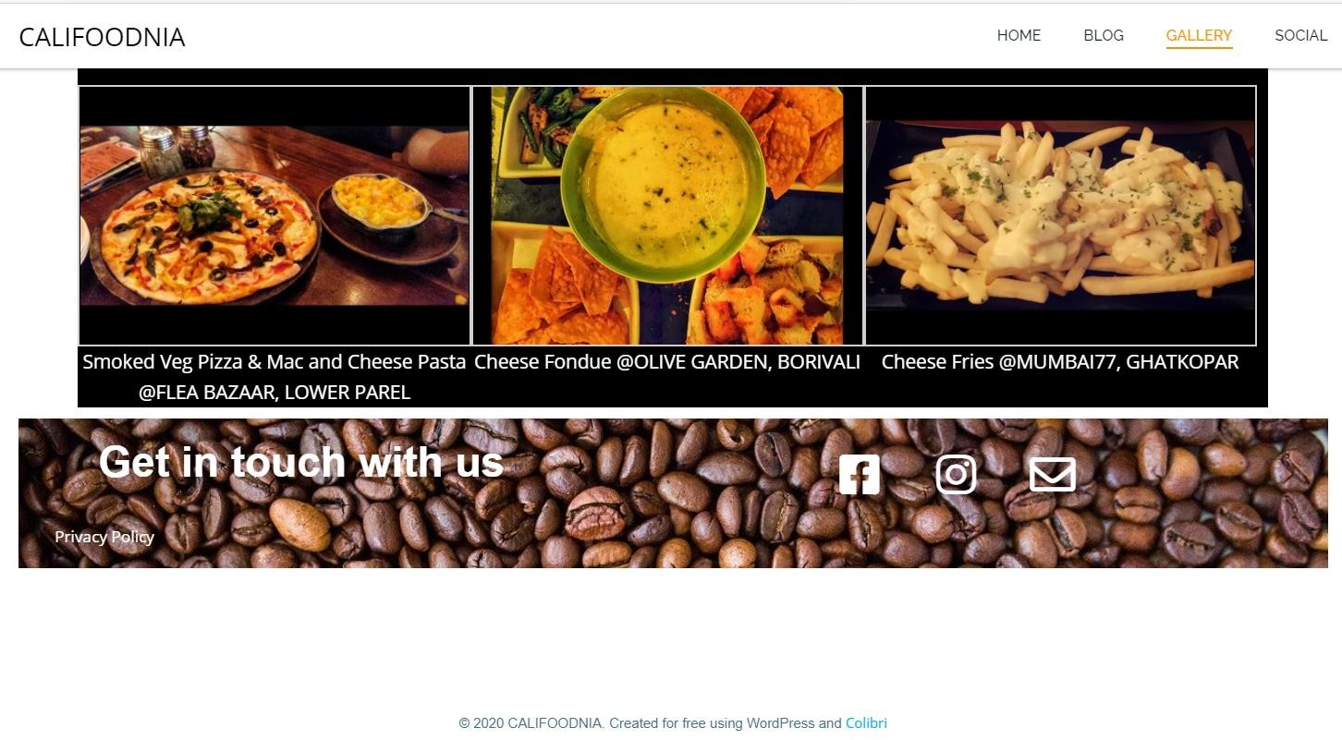

The footer of the page looks a lot bland. The footer in order to look good , always has to be kept at the bottom of the page as a sticky footer with position as static. Also, the line for copyright should be a part of the footer.

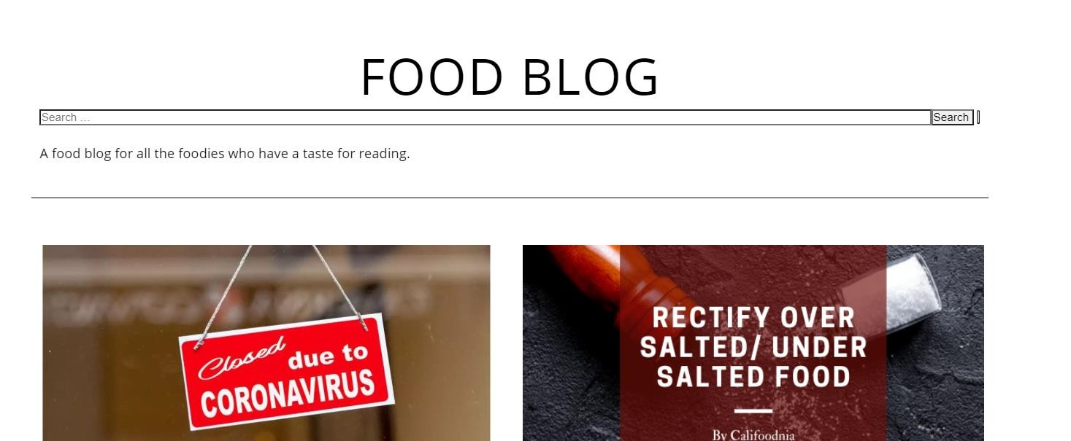

The search box in the blog page and the social page is very ugly looking as compared to the rest of the page.

If some css styles are applied to the page, then the page will look good as a

whole.





1. Have you previously ever worked with a SEO firm, what was your experience and what challenges did you face there?
2. What are the keywords that you have researched in the past?
3. Do you have a robots.txt file included in your website?
4. Do you have a personal google analytics/google web master tools account of yours?



1. Do you have a previous domain name of yours?
2. Would you prefer to give us the details of your previous google analytics report?
3. Is there anything that you would like me to convey to my seniors?